Quiz 4.1 REVIEW – Honors Name: ____________________________________

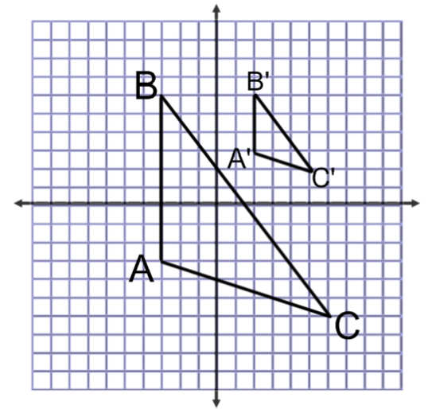
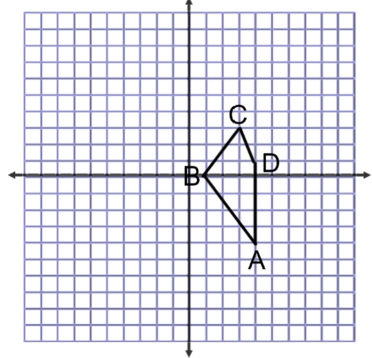
1. Dilate the image by 3 around the point (4,-2) 2. Find the scale factor and the center dilation

3. Are these triangles similar? 4. Are these triangles similar?
If so, by what theorem? If so, by what theorem?
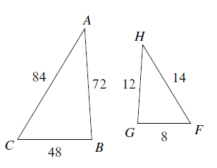
Justify with work. Justify with work.
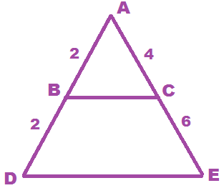

5. Are these triangles similar?
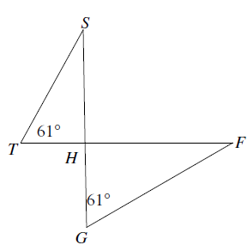
If so, by what theorem?
Justify with work.

Statements | Reasons
8. Given: $AC=27; BC=21$
$EC=14; DC=18$

Prove: $∆BCA\sim ∆ECD$

Statements | Reasons

9. Given: $\overline{AE}∥\overline{BD}$
Prove: $∆ACE\sim ∆BCD$

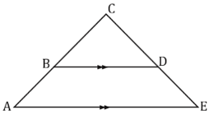

10.
Suppose a new triangle is constructed with vertices D, E, and F. Which of the following sets of information about the new triangle are sufficient to prove that the new triangle is similar to $∆ABC$? Choose all that apply.
a] $EF=18.66 cm$
$DE=24.40 cm$

b] $m∠D=23°$
$m∠F=31°$

c] $m∠F=31°$
$DE=12.20 cm$

d] $m∠F=126°$
$DF=38.42 cm$
$DE=24.40 cm$

e] $m∠F=126°$
$DF=38.42 cm$
$EF=18.66 cm$

11. Which of the following sets of conditions could be used to prove $∆ABC\sim ∆PQR$? Select all that apply.
c] $∠B≅∠Q$

$∠C≅∠R$

d] $\frac{AB}{PQ}=\frac{BC}{QR}=\frac{AC}{PR}$

e] $\frac{AB}{PQ}=\frac{BC}{QR}$
a] $∠B≅∠Q$

$\frac{BC}{QR}=\frac{AC}{PR}$

b] $∠A≅∠P$

$\frac{AC}{PR}=\frac{AB}{PQ}$

