Classwork – Review after PARCC Name: ____________________________________

Warm Up
Find the Five Number Summary for the following:
25, 32, 34, 38, 40, 55, 57, 79

Min Lower Quartile Median Upper Quartile Max

Make a Box-and-Whisker Plot

- Below is a table for an object’s height over a period of time:

- Use a calculator and make a scatterplot to determine the best model (linear, exponential or quadratic.)

- Write the equation to best represent $H\left(t\right)= ______________________________$

- Use your model to predict the height after 7 seconds. ______________________________

- Explain how to find the MEAN of a set of numbers?

- Explain how to find the MEDIAN of a set of numbers?

- Explain how to find the MODE of a set of numbers?

- Given the following data:

- Find each for the data above.

Mean: Median: Mode: Range:

- If the is changed to a 14, what would happen to each of the following?

Mean: Median: Mode: Range:
- Given the following Box-and-Whisker Plot “Scores on a Quiz”
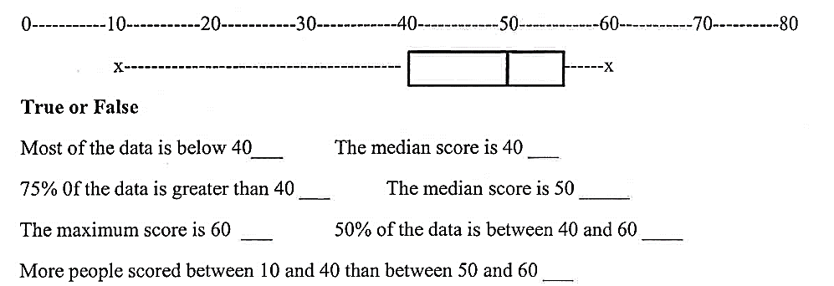

- Find the Range. ___________

- Find the Interquartile Range. ___________

- Given the following TEST SCORES… Which of the following is true?
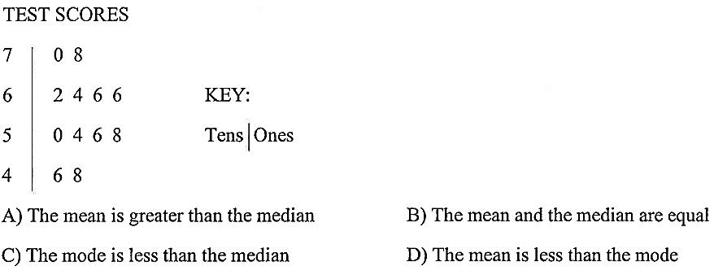

- Write the Five Number Summary _________ _________ _________ _________ _________

- What was the mean of the test scores? _________

- What was the median of the test scores? _________

- What was the mode of the test scores? _________

