Redemption Homework Name: ____________________________________
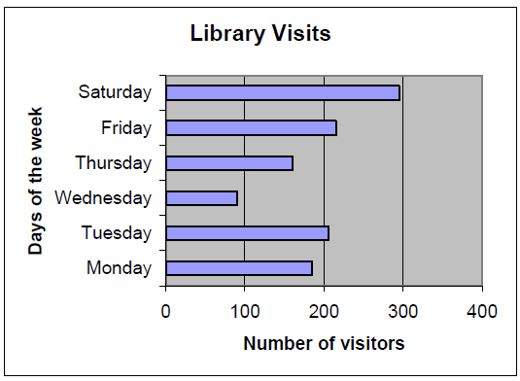
- On which day did the library receive the most visitors?

- Approximately how many visitors came to the library that day?

- Why do you think that day had the most visitors?

- Describe the pattern you see in the number of visitors from Wednesday to Saturday.

- Create one question that could be answered from the graph.

- Tony has a cake shop. This month he sold the following number of cakes:
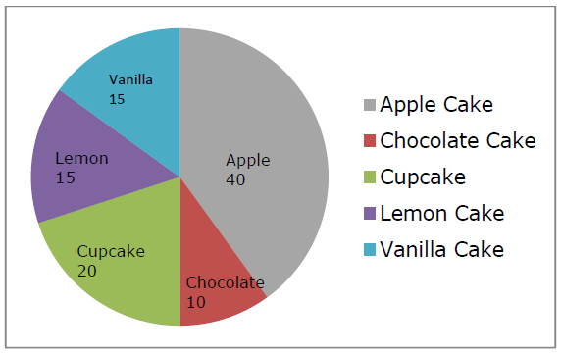
- How many apple cakes sold in a month?

- Which two cakes sold in the same volume?

- Which cake sold more than lemon cakes?

- Which cakes were most popular?

- 100 students voted on their favorite family member. Mother was the most popular choice. The results of voting can be seen below in the frequency table. Create a bar graph using the space below.

Family Member | Frequency
Father | 30
Mother | 40
Sister | 18
Brother | 12

