Exit Ticket – Secant & Tangent Angles Name: ________________________________

For #’s 1-2 verify if line AB is tangent to the circle.
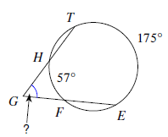
1. 2. 3. Solve for$∠TGE$.

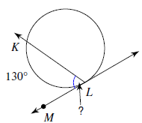
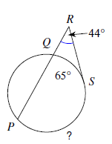
4. Solve for$\hat{PS}$. 5. Solve for$∠KLM$. 6. Solve for the indicated angle.

Exit Ticket – Secant & Tangent Angles Name: ________________________________

For #’s 1-2 verify if line AB is tangent to the circle.
1. 2. 3. Solve for$∠TGE$.

4. Solve for$\hat{PS}$. 5. Solve for$∠KLM$. 6. Solve for the indicated angle

