Homework 4.7 – Mid-Segment Theorem Day 1 – Honors Name: ____________________________________

3. The following figure shows $∆ABC$ with side lengths $AB=10$, $BC=8$, and $CA=5.$ Segment $\overline{DE}$ is constructed to be parallel to $\overline{AB}$ and to originate at point D, the midpoint of $\overline{AC}$. In the spaces below, enter the lengths for the requested segments.

$BE= ___________$ $ED= ___________$

$$DA= ___________$$

1. Find the following: 2. Find the following:
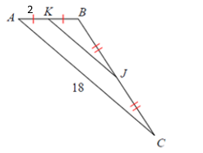

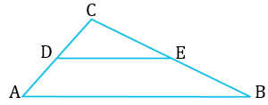
$KJ= ___________$ $PQ= ___________$

$AB= ___________$ $TP= ___________$

$TS= ___________$

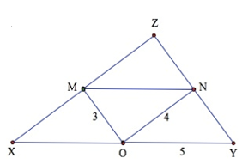
4. Find the length of the following if points M, N, and O are the midpoints of the sides.

$XO= ___________$ $ZN= ___________$

$NY= ___________$ $MN= ___________$

$ZY= ___________$ $XZ= ___________$

5. Given that there is a mid-segment, solve for $x$ and solve for $y$.

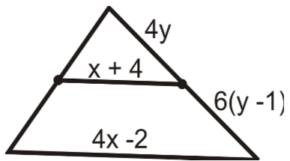

6. Use the diagram of $∆ABC$ where D, E, and F are the midpoints of the sides.
Facts: $AE=16$, $FE=26$, $AB=5y+7$, $DF=-3x-5$

Solve for $x$: Solve for $y$:

