Homework 6.6 – Exterior Circle Angles Day 2 – Honors Name: ____________________________________

Directions: Solve for the measure of the “?” in each problem.
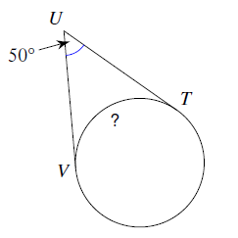
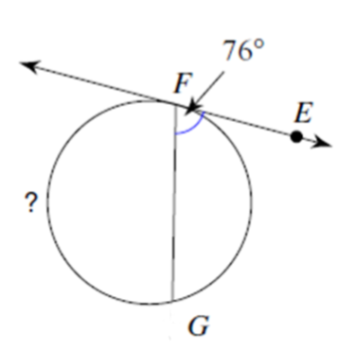
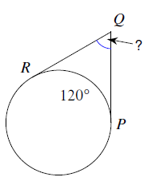
1. 2. 3.

213$°$

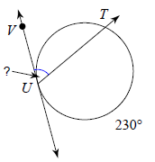
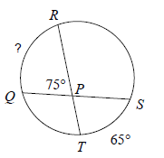
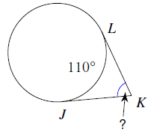
4. 5. 6.

Homework 6.6 – Exterior Circle Angles Day 2 – Honors Name: ____________________________________

Directions: Solve for the measure of the “?” in each problem.
1. 2. 3.

213$°$

4. 5. 6.

