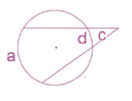

**Round A**

c =_________________

Given 2 secants, a=160°. Find c.

Given 2 secants, x=20°. Find a.

a =_________________

d =_________________

Given 2 secants, a=168°, find d.

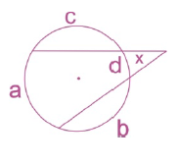

x = ______________