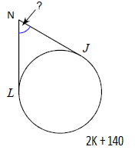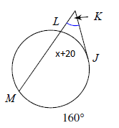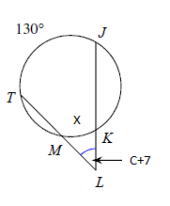

N =_________________

Find N.

Find K.

Find x.

Find C.

**Round B**

K =_________________

x =_________________

C = ______________