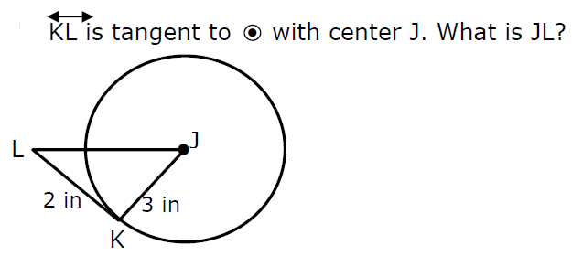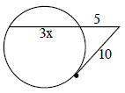

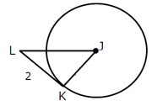

c

a

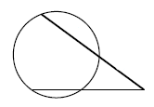

d

4

5

c

Given 2 secants. Find c.

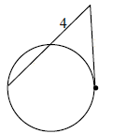

x

d

Given a secant and a tangent, solve for d.

Given a secant and a tangent, solve for x.

**Round C**

c =_________________

a =_________________

d =_________________

x = ______________