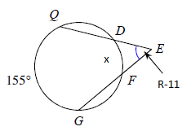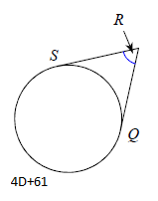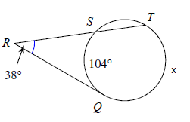

D =_________________

Find x.

Find x.

Find R.

Find D.

**Round D**

R =_________________

x =_________________

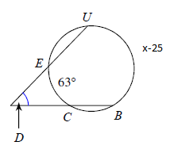

x = ______________