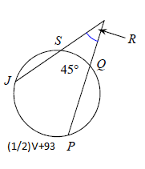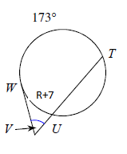

Find U.

Find R.

Find V.

Find R.

**Round E**

V =_________________

R =_________________

R =_________________

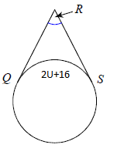

U = ______________