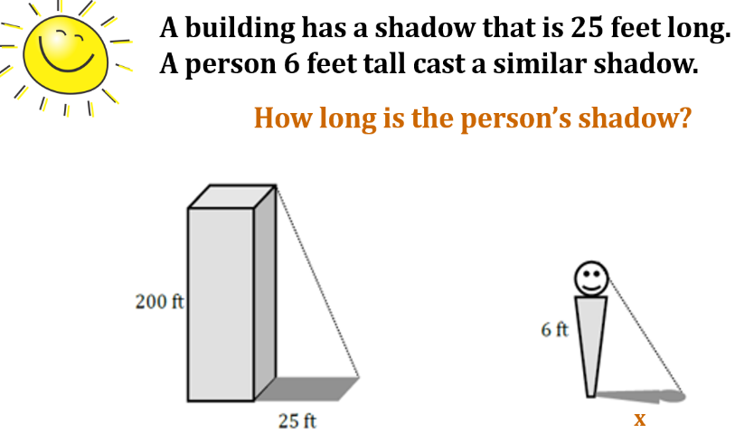**Notes:** Similarity Application Name: _________________________________

