Classwork: Derive & Practrice the Equation of a Circle

Name: ____________________________________
Consider the circle in a coordinate plane that has its center at $C(h, k)$ and that has a radius r.
A
A) Let P be any point on the circle and let the coordinates of P be $(x, y)$.

Create a right triangle by drawing a horizontal line through C and a vertical line through P, as shown.

- What are the coordinates of point A? __________________

- Write expressions for the lengths of the legs of $∆CAP$.

$CA=$ ____________________; $PA=$ ______________________
B
B) Use the Pythagorean Theorem to write a relationship among the side lengths of $∆CAP$.

_______________________ + _________________________ = _____________________

C
C) Equation of a Circle:

$(h, k)$ is the _______________________________

$r$ is the ___________________

$(x, y)$ is _______________________________________________

- What is the equation of a circle whose center is at (3 , -8) and radius is 5?

- What is the equation of a circle whose center is at (6.5 , 9) and radius is $\sqrt{5}$?

- What is the center and the radius of the circle whose equations is ${(x-1)}^{2}+ {(y+4)}^{2}=25$.

- What is the center and the radius of the circle whose equations is ${(x+2)}^{2}+ {(y+7)}^{2}=13$.

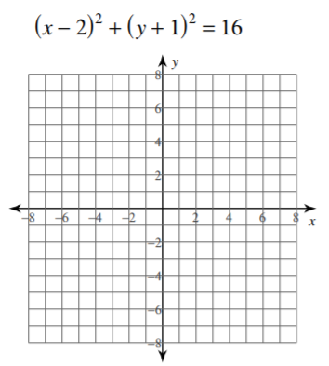
Identify the center and radius of each. Then sketch the graph.
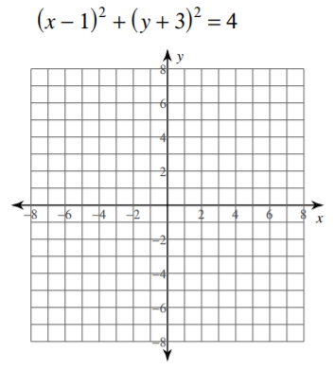
- 6.

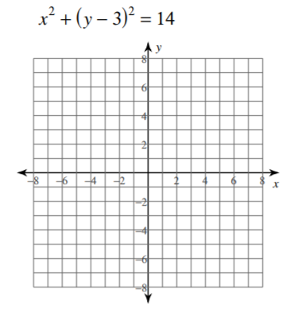
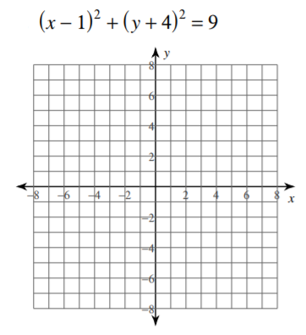
- 8.

Use the information provided to write the equation of each circle. (Really gotta use your brain in #10!)

- Center: $\left(13, -13\right)$ 10. Center: $\left(-13, -16\right)$
Radius: $4$ Point on Circle: $(-10, -16)$

