PARCC Practice
Login to the computer using your school login.
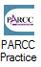
On your XIA links select: This will take you to the website, https://parcc.pearson.com/practice-tests/

Select View Mathematics Practice Tests on this page. Since we are taking Algebra I, scroll down and select Algebra I. We are going to take Unit 1: Computer Based
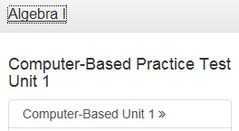
Login as Guest. There are 2 sections, the first is non-calculator (10 questions) and the second is a calculator (4 questions). Please read the directions for each section.
You will be graded on showing your work for all 14 questions in this unit on a sheet of paper. We have found that students do little work on paper and therefore are not as successful.

PARCC Practice
Login to the computer using your school login.
On your XIA links select: This will take you to the website, https://parcc.pearson.com/practice-tests/

Select View Mathematics Practice Tests on this page. Since we are taking Algebra I, scroll down and select Algebra I. We are going to take Unit 1: Computer Based
Login as Guest. There are 2 sections, the first is non-calculator (10 questions) and the second is a calculator (4 questions). Please read the directions for each section.
You will be graded on showing your work for all 14 questions in this unit on a sheet of paper. We have found that students do little work on paper and therefore are not as successful.

