PARCC Review – Practice Test 1 Name: ______________________________
Directions: Log onto the computer. In your XIA links select, PARCC Practice and select the View Mathematics Practice Tests and select Algebra I (Computer Based Unit 1). You will be a Guest and select Start and Start again on the Non-Calculator. Use the following sheet, to record your answers.

1. Determine the zeros. Select all that apply.  -48 -8 -6 -4 -2 0 2 4 6 8 48 |  |  | Notes:
2. Let $a$ and $b$ be rational numbers and $c$ be irrational.  Part A  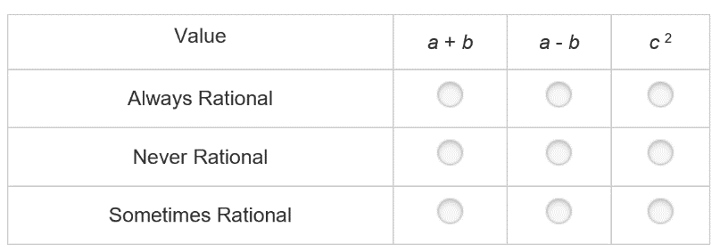 |  |  | Part B  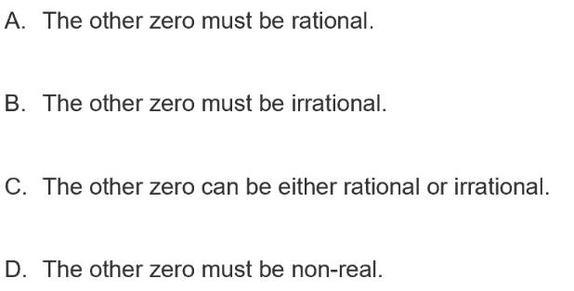 |  |  |  | Notes:
3. Graph  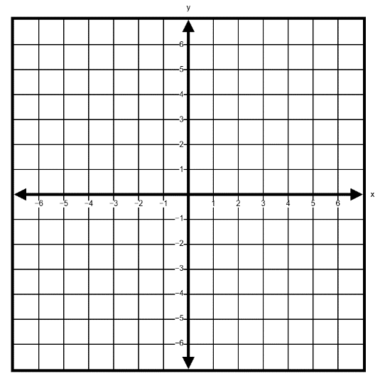 |  |  |  | Notes:
4. Find the zeros using Factoring  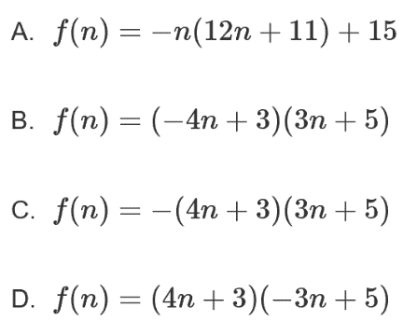 |  |  |  | Notes:
5. Which expression is equivalent?  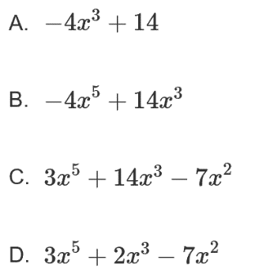 |  |  |  | Notes:
6. Part A  $x:$  $y:$ |  |  |  | Part B |  | Notes:
7. What is the value of $k$?  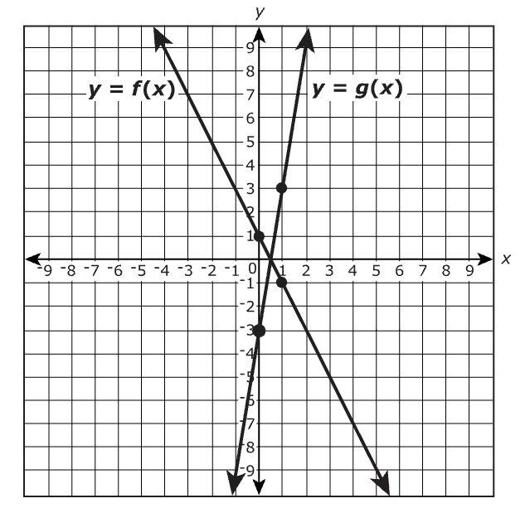  $k=$ |  |  |  | Notes:
8. $f(x)$ $g\left(x\right)=-3x+2$  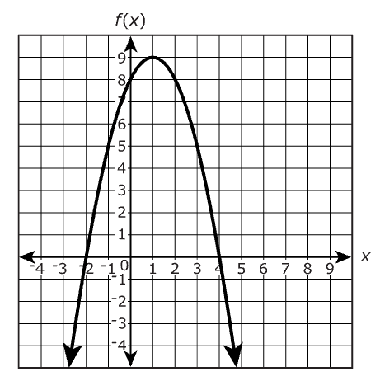  $$f(2)__________g(2)$$  $$f(-2)______________g(-2)$$ |  |  |  | Notes:
9. Graph  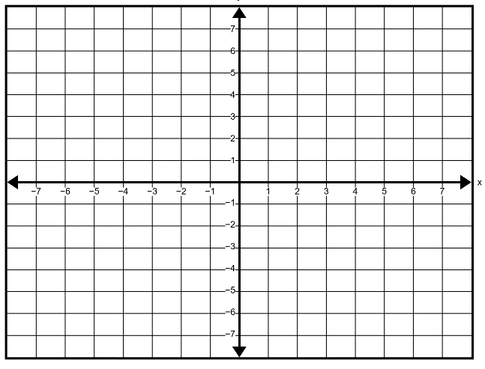 |  |  |  | Notes:
10. $x:$  $C\left(x\right):$  If $C\left(4\right)=398$ |  |  |  | Notes:
11. Part A  $x:$  $y:$  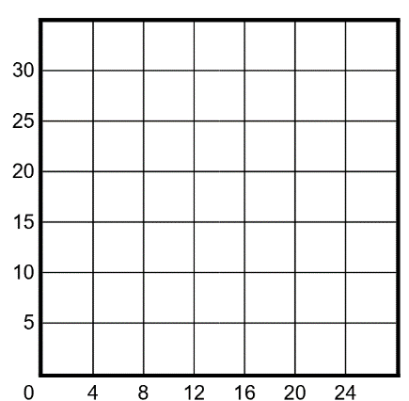 | Part B  Select all that apply  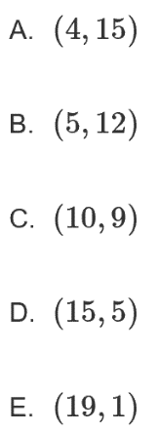 |  |  |  | Notes:
Part C  Number of Hours? | Part D  Number of Hours? |  |  |  | Notes:
12. Part A  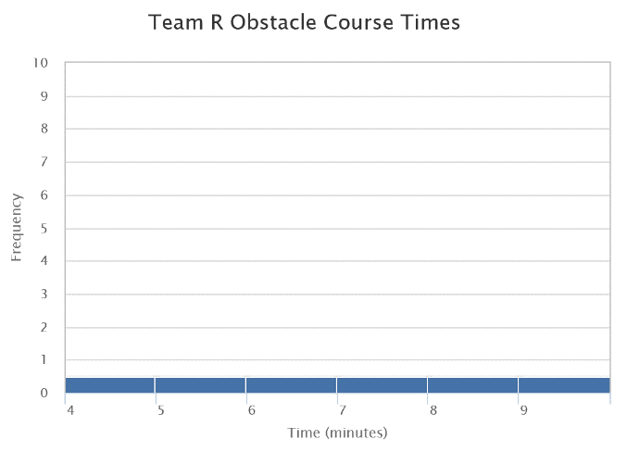 | Part B  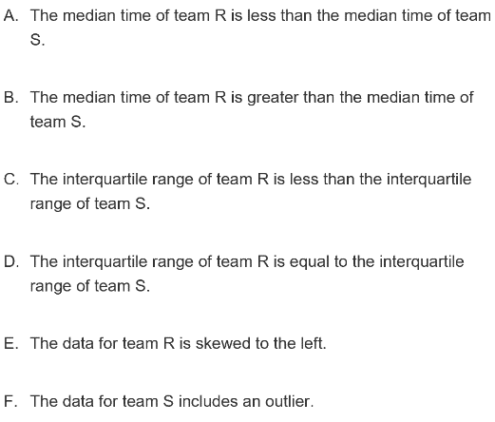 |  |  |  | Notes:
13. Part A  Equation:  Explanation: | Part B  # of Cookies for Phil:  # of Cookies for Matt:  Show work that lead to answer: |  |  |  | Notes:
Part C  Should price be raised?  Justify your answer: |  | Notes:
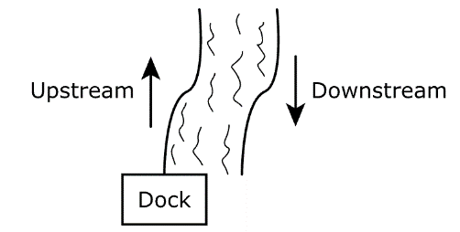  14. Steps and Justification: |  | Notes:

