Conversion Practice – Unit Circle - Hon Geometry Name: ________________________

**DEGREE and RADIANS INTRODUCTION**

**RADIAN AND DEGREE CONVERSION**

*If 360 $°$ = 2π radians OR 180 $°$ = π radians, then to convert between the angle measurements…*

**DEGREES to RADIANS:**



**Example:**

**a) 40 🡪  or 0.698 radians**

**b) 250 🡪  or 4.363 radians**

**RADIANS to DEGREES:**



**Example:**

**a) 🡪 **

**b) 0.5 🡪 **

**CONVERSION PRACTICE:**

**(1) Convert the degree of the angle to radian measure (round to 3 decimal places)**

**1a. 31 $°$**

**1b. 147 $°$**

**1c. 293 $°$**

**1d. 630 $°$**

**1e. 434 $°$**

**1f. -225 $°$**

**(2) Convert the degree of the angle to exact radian measure (π as a symbol and fractions)**

**2a. 35 $°$**

**2b. 160 $°$**

**2c. -15 $°$**

**2d. 660 $°$**

**2e. 434 $°$**

**2f. - 10 $°$**

**(3) Convert the radian measure to degrees (round to 3 decimal places)**

**3a. 1.4**

**3b. 0.33**

**3c. 0.68**

**3d. 6.56**

**3e. 5.8**

**3f. 9**

**(4) Convert the radian measure to exact degree.**

**4a. **

**4b. **

**4c. **

**4d. **

**4e. **

**4f. **

**CIRCLE and ANGLES:**

**Angles of a circle are measured from starting on the positive portion of the x-axis.**

* **POSITIVE Angle Measures 🡪 COUNTER CLOCKWISE Rotation**
* **NEGATIVE Angle Measures 🡪 CLOCKWISE Rotation**

**DEGREE:**

**360 $°$ is the angle measure of a circle**

**RADIANS:**

**2π radians is the angle measure of a circle**

**COTERMINAL ANGLES: Angles that have same location in a circle.**

* *Coterminal angles differ by addition or subtraction multiple of 360*
* Example: 120 $°$, - 240 $°$, 480 $°$ are all coterminal. (120 $°$– 360 $°$ = -240 $°$; 120 $°$ + 360 $°$ = 480 $°$)

**I. Define the intervals in DEGREE measure for each quadrant of the coordinate plane.** (See Below Circle)

**Quadrant I: __________ Quadrant II: __________ Quadrant III: __________ Quadrant IV: __________**

**II. Label each given angle of the circle in EXACT RADIAN measure:**

Do you notice any pattern in denominators of the radians?

0 $°$ = ___________

30 $°$ = ___________

360 $°$ = ___________

90 $°$ = ___________

60 $°$ = ___________

45 $°$ = ___________

330 $°$ = ___________

315 $°$ = ___________

300 $°$ = ___________

270 $°$ = ___________

___________ = 240 $°$

___________ = 120 $°$

___________ = 135 $°$

___________ = 150 $°$

___________ = 180 $°$

___________ = 210 $°$

___________ = 225

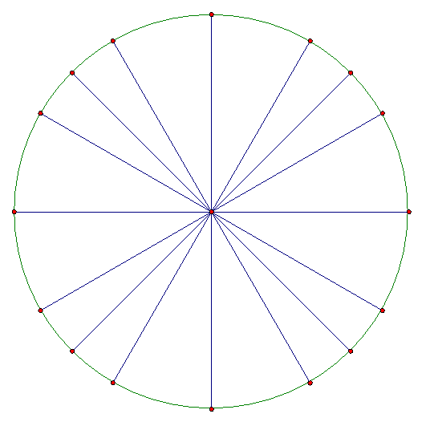

**III. Define the intervals in RADIAN angle measure for each quadrant of the coordinate plane.**

**Quadrant I: __________ Quadrant II: __________ Quadrant III: __________ Quadrant IV: __________**