Homework 4.7 – Quadratic Graph Features Name: ________________________________________

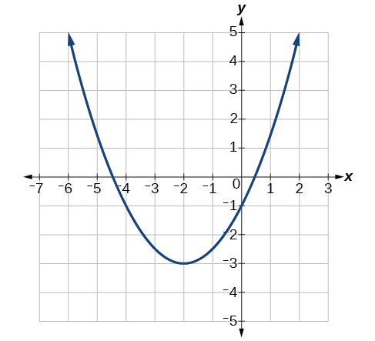
Identify the following:

- Zeros ($x-$intercepts):

- Vertical Intercept ($y-$intercept):

- [circle one] Maximum or Minimum?

- Vertex:

- Does the parabola open up or down?

- Axis of Symmetry:

- Domain:

- Range:

- Average rate of change from $x=-2$ to $x=0$

Homework 4.7 – Quadratic Graph Features Name: ________________________________________

Identify the following:

- Zeros ($x-$intercepts):

- Vertical Intercept ($y-$intercept):

- [circle one] Maximum or Minimum?

- Vertex:

- Does the parabola open up or down?

- Axis of Symmetry:

- Domain:

- Range:

- Average rate of change from $x=-2$ to $x=0$

