Homework 6.10 - Radian Conversion Name: ___________________________
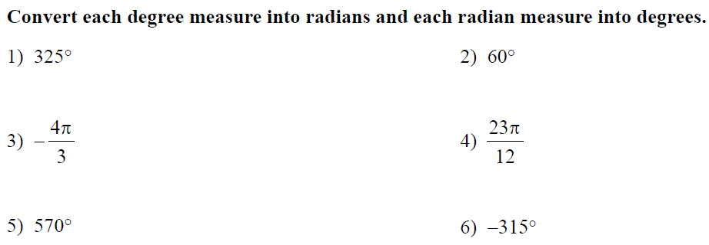
7) You are eating an 8th of a pizza. What is the central angle that the pizza pie was cut at, in radians, such that each slice is equal?

8) You are eating chocolate pie. The crust length (aka arc length) was 3 inches. The diameter of the pie was 12 inches. What is the angle, in radians, that the pie was cut such that each piece is equal? What is the measure in degrees?

Homework 6.10 - Radian Conversion Name: ___________________________
7) You are eating an 8th of a pizza. What is the central angle that the pizza pie was cut at, in radians, such that each slice is equal?

8) You are eating chocolate pie. The crust length (aka arc length) was 3 inches. The diameter of the pie was 12 inches. What is the angle, in radians, that the pie was cut such that each piece is equal? What is the measure in degrees?

