Homework 6.11 - Converting/Area of a Sector Name: ____________________________________

**Convert from degrees to radians and radians to degrees.**

1)  2) 47 o 3)  4) 210 5)  6) 100 o

**Find the area of the sector for problems 7-10**

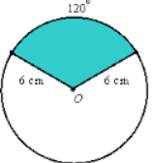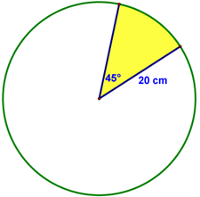7) Radius=4 8) Radius=3 9) 10)   
Angle= Angle= 65 o

Homework 6.11 - Converting/Area of a Sector Name: ____________________________________

**Convert from degrees to radians and radians to degrees.**

1)  2) 47 o 3)  4) 210 5)  6) 100 o

**Find the area of the sector for problems 7-10**

7) Radius=4 8) Radius=3 9) 10)   
Angle= Angle= 65 o