Unit 6 Test Review Sheet – Honors Name: ____________________________________
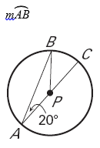
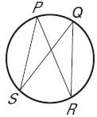
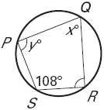
1. m$∠x$ and m$∠y$? 2. If $∠$SPR = 33$°$ then what is the m$∠$RQS? 3.

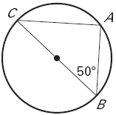
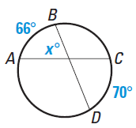
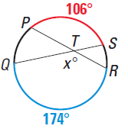
4. m$∠$x? 5. m$∠$x? 6. m$∠$C?

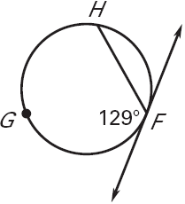
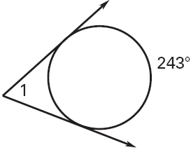
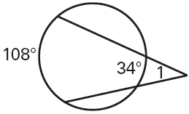
7. m$\hat{FH}$ 8. m$∠$1 9. m$∠$1

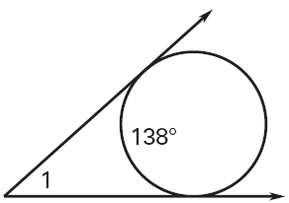
10. m$∠$1 11. m$∠$1 12. Length of x
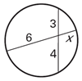
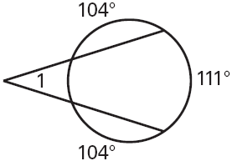

13. Convert the following from degrees to radians or vice versa.
a) 34$°$ b)$\frac{4π}{3}$
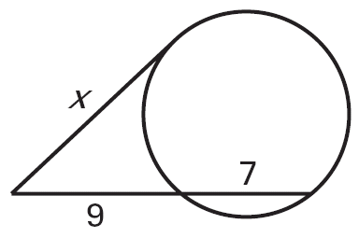
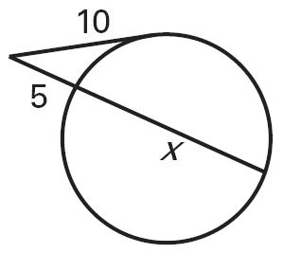
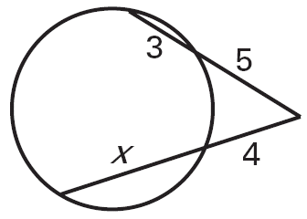
14. Length of x 15. Length of x 16. Length of x

17. Area of Sector POQ 18. Area of Sector ACB 19. Area of Sector ACB
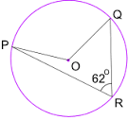
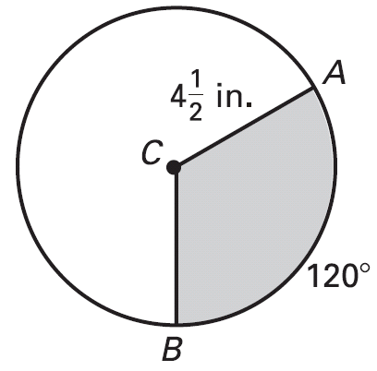
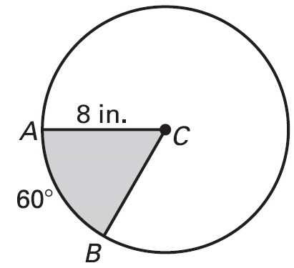
5

20. What is the equation of the circle whose center is (-2, 5) and radius = 3?

21. What is the equation of the circle who has a point (3, 2) and the center is (5, 0)?

22. What is the center and radius of the circle: $x^{2}+y^{2}+6x-8y=0$?

23. Find the center and the radius of the circle. Then prove or disprove that the point (2, 5) is on the circle whose equation is ${(x-4)}^{2}+{(y+6)}^{2}=125$

24. Find the center and the radius of the circle. Then prove or disprove that the point (3, 3) is on the circle whose equation is $x^{2}+y^{2}+6x-14y-12=0$?

