Classwork – Quadratics Review Name: _________________________
You will be turning this in at the end of class for a grade.
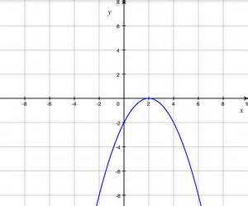
1. Use the graph to answer the following questions:
Part A: On what interval is the graph decreasing?

Part B: What is the vertex?

Part C: What is the average rate of change from $x=2$ to $x=6$?

__________________________________________________________________________________
2. Rewrite the function $f\left(x\right)= x^{2}+12x+32$ in vertex form by completing the square. Find the vertex and the axis of symmetry.

__________________________________________________________________________________
3. Use the quadratic formula to find the roots (zeros) of the function ${2x}^{2}+3x-11=0$.

__________________________________________________________________________________
4. An object is launched at 24.4 meters per second (m/s) from a 62.1-meter tall platform. The equation for the object's height $s$ at time $t$ seconds after launch is $s\left(t\right)=-4.9t^{2}+24.4t+62.1$, where $s$ is in meters. When does the object strike the ground?

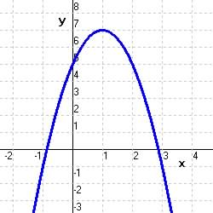
5. What is the domain and range, in inequality notation, of this graph?

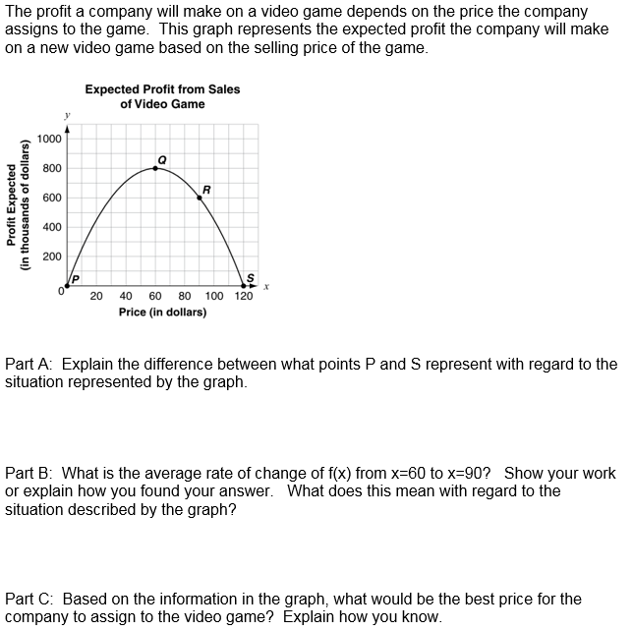
6.

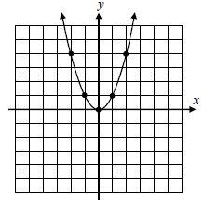
7. The coordinate plane below shows the graph of
$y= x^{2}$. On the same graph, draw the following quadratic functions. You need to plot a minimum of five points.
- $y= x^{2}-5$

- $y={\left(x-4\right)}^{2}$

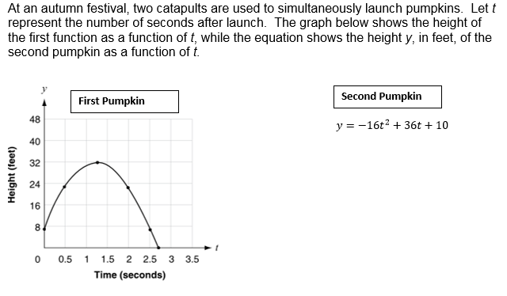
8.

Part A: About how much higher is the second pumpkin than the first at the time of launch? Show your work or explain your reasoning.

Part B: What is the difference of the maximum heights of the two pumpkins? Show your work or explain your reasoning.

