Redemption Homework – PARCC Review Name: ____________________________________

- A student started an online discussion group. This table shows the number of registered members each month for the first sixth months after the group was started.
Part A: Would a linear function be a good fit for these data? Explain why or why not.

Part B: Write a function that could be a model for these data. Justify mathematically that your function is a good fit.

Part C: Estimate the number of members in the club after 24 months. Explain how you got your answer.

- Madison created two functions.

For Function A, the value of $y$ is two less than four times the value of $x$.

The table below represents Function B.
In comparing the rates of change, which statement about Function A and Function B is true?

[a] Function A and Function B have the same rate of change

[b] Function A has a greater rate of change than Function B has.

[c] Function A and Function B both have negative rates of change

[d] Function A has a negative rate of change and Function B has a positive rate of
change.

- The value, $V$, of an investment is given by the function $V(t)$, where $t$ is the number of years since 1995 and $V$ is measured in thousands of dollars. Which equation indicates that the investment had a value of $8,000 in 2005?

[a] $V\left(8\right)=10$ [c] $V\left(2005\right)=8,000$

[b] $V\left(10\right)=8$ [d] $V\left(8,000\right)=2005$

- A linear function $f(x)$ has these values.

$$f\left(3\right)=5$$

$$f\left(10\right)=26$$

What is the value of $f\left(6\right)?$

[a] 11 [c] 17

[b] 14 [d] 20

- An online electronics store must sell at least $2500 worth of printers and computers per day. Each printer costs $50 and each computer costs $500. The store can ship a maximum of 15 items per day.

Part A: On the axes below, graph a system of inequalities that models these constraints.
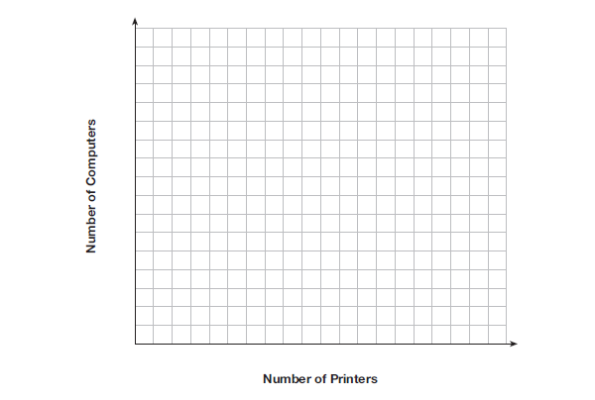
Part B: Determine a combination of printers and computers that would allow the electronics store to meet all of the constraints. Explain how you obtained your answer.

- Function $h$ is described by the equation $h\left(t\right)=-16t^{2}+16t+6.$

The table shows pairs of values for a quadratic function $g\left(t\right).$

What is the difference between the maximum values of the graphs for the two functions?

[a] 1

[b] 10

[c] 11

[d] 21

