PARCC REVIEW SHEET 1 Name: ____________________________________
Do NOT lose this! FINISH IT BY MONDAY.
Unit 1 Functions:
- Jerome is constructing a table of values that satisfies the definition of a function.

What number(s) can be placed in the empty cell so that the table of values satisfies the definition of a function? Select all that apply.

- -5
- -1
- 0
- 2
- 11
- 17
- Which of these relations does not describe a function?
- The set of ordered pairs (x,y) where x and y are real numbers and $y^{2}=x.$
- The set of ordered pairs (x,y) where x and y are positive real numbers and y²=x
- The set of ordered pairs (x,y) where x and y are positive real numbers and $y=3x-2$
- The set of ordered pairs (x,y) where x and y are real numbers and $y=3x-2$
- Jim is planning a party. He spends $150 on a room for the party. He also spends $16.50 per person for food. Jim finds the total cost of the party of be f(p) where p is the number of people at the party. What is f(35)? [Requires Work]

- A pattern of blocks is shown below.

If the pattern of blocks continues, which formula(s) could be used to determine the number of blocks in the nth term? Select all that apply

- $a_{n}=n+4$
- $a_{n}=4n-2$
- $a_{n}=4n+2$
- $a_{n}=2n+4$
- $a_{1}=2, { a}_{n+1}=a_{n}+4$, where $n≥1$
- $a_{1}=2, { a}_{n}=a_{n-1}+4$, where $n≥1$
- $a_{1}=2, { a}_{n}=a_{n-1}+4$, where $n≥2$
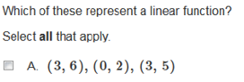
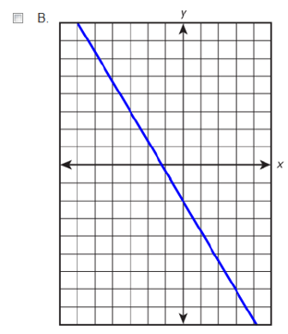
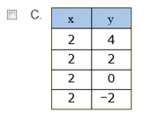
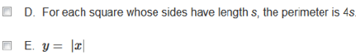
Unit 2-4 Linear Functions:
[Requires Work]

- Ava is considering the price she should charge for the new menu item at her restaurant. She did some market research and found that 20 people ordered the item when she set the price at $4. When she set the price at $8, she found that 10 people ordered the item. Ava thinks there might be a linear relationship between the price and the number of people who will order the item. [Requires Work]

- $f\left(2\right)=9 and f\left(8\right)=45$ then what is the value of $f\left(4\right)?$ [Requires Work]
- 15
- 19
- 21
- 27
- The students in the freshman class plan to use the profits from selling hats for a class trip. The cost to have 200 hats made is $1500. They will be sold for $12 each. [Requires Work]
Part A: Write an equation to represent the profit, p, earned from selling x hats.

Part B: Suppose the class decides to charge $15 per hat instead of $12. At this selling price, how many fewer hats must be sold to recover the cost of making the 200 hats? Show your work or explain how you found your answer.
5. Bailey, Jeremiah, and Maggie are buying school supplies. Bailey buys 2 pens and 6 pencils and spends a total of $7.00. Jeremiah buys 3 pens and 5 pencils and spends a total of $7.50. [Requires Work]
Set up a system of equations in order to find out how much will Maggie spend to purchase 4 pens.

PARCC REVIEW SHEET 2 Name: ____________________________________
Do NOT take this home with you!
Unit 5 Exponentials:
- A car’s value depreciates exponentially every year after it is purchased. The value, C¸ of the car t years after it was purchased can be approximated by the function $=25.6{(0.75)}^{t}$ , where C is in thousands of dollars.
[Requires Work]
Part A: What does the number 25.6 represent in the context of the situation? Show your work or explain your reasoning.

Part B: Describe the change in C when t increases by one year. Show your work or explain your reasoning.
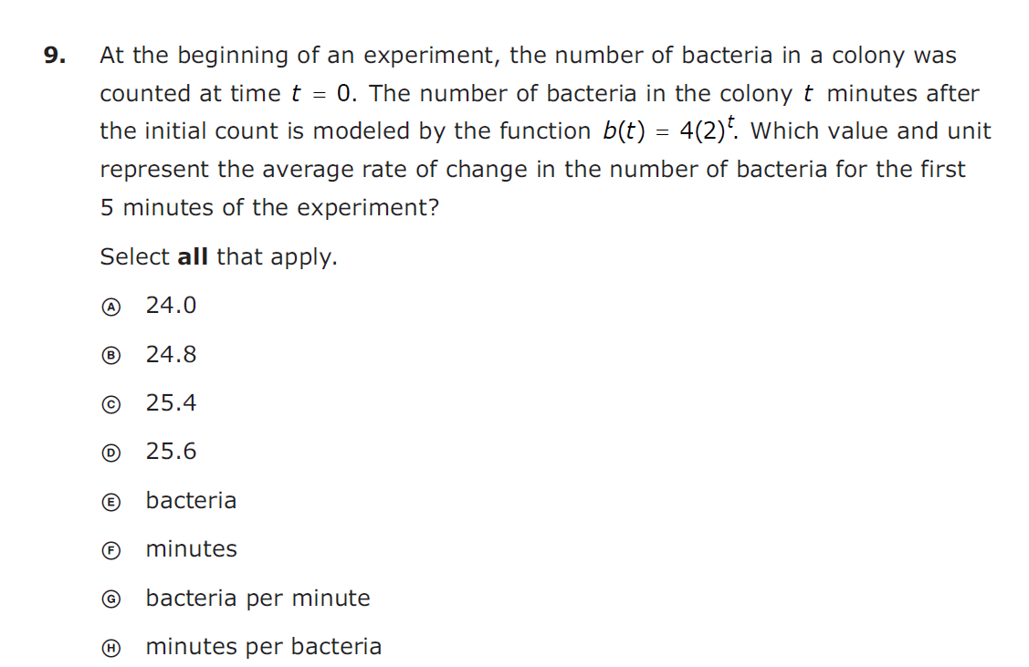

[Requires Work]

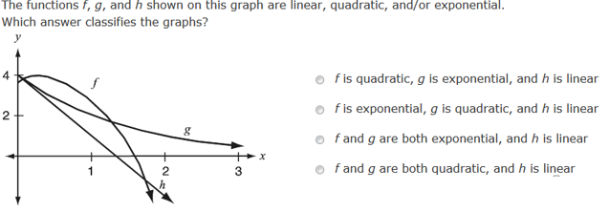

Unit 6 Quadratic Equations:

- At an autumn festival, two catapults are used to simultaneously launch pumpkins. Let t represent the number of seconds after launch. The graph below shows the height of the first function as a function of t, while the equation shows the height y, in feet, of the second pumpkin as a function of t. [Requires Work]

Second Pumpkin
First Pumpkin
$$y=-16t^{2}+36t+10$$

Part A: About how much higher is the second pumpkin than the first at the time of launch? Show your work or explain your reasoning.

Part B: What is the difference of the maximum heights of the two pumpkins? Show your work or explain your reasoning.

- In the equation $x^{2}+10x+24=\left(x+a\right)\left(x+b\right), b$ is an integer. Find algebraically all possible values of b.

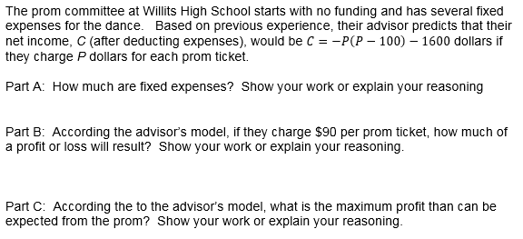

[Requires Work]

