Practice: Solving Missing Sides w/ Proportions Name: _____________________

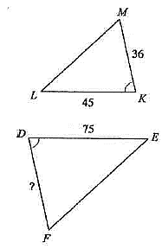
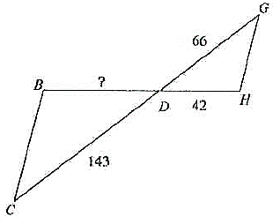
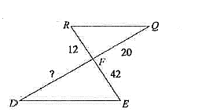
1. $∆RQF\sim ∆EDF$ 2. $∆BDC\sim ∆HDG$ 3. $∆DEF\sim ∆KLM$

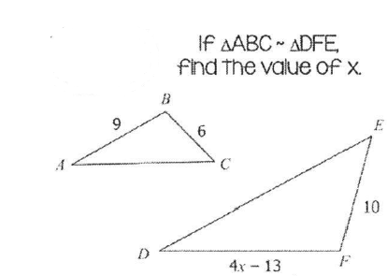
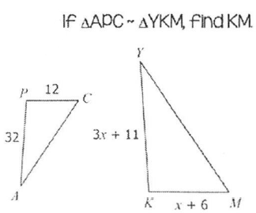
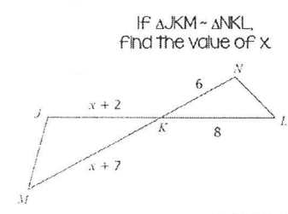
4. 5. 6.

Practice: Solving Missing Sides w/ Proportions Name: _____________________

1. $∆RQF\sim ∆EDF$ 2. $∆BDC\sim ∆HDG$ 3. $∆DEF\sim ∆KLM$

4. 5. 6.

