Homework 5.2 – Trigonometry Ratios Name: ____________________________________

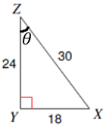
Compute all three trig ratios for the given reference angle.
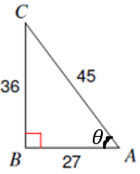
1. $Sin\left(A\right)= __________$____ 2. $Sin\left(θ\right)= __________$____

$Cos\left(A\right)= __________$____ $Cos\left(θ\right)= ______________$
$Tan\left(A\right)= __________$____ $Tan\left(θ\right)= ______________$

3. $Sin\left(C\right)= __________$____ 4. $Sin\left(θ\right)= __________$____

$Cos\left(C\right)= __________$____ $Cos\left(θ\right)= ______________$
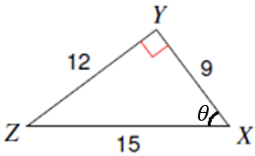
$Tan\left(C\right)= __________$____ $Tan\left(θ\right)= ______________$
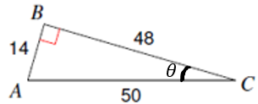

Homework 5.2 – Trigonometry Ratios Name: ____________________________________

Compute all three trig ratios for the given reference angle.
1. $Sin\left(A\right)= __________$____ 2. $Sin\left(θ\right)= __________$____

$Cos\left(A\right)= __________$____ $Cos\left(θ\right)= ______________$
$Tan\left(A\right)= __________$____ $Tan\left(θ\right)= ______________$

3. $Sin\left(C\right)= __________$____ 4. $Sin\left(θ\right)= __________$____

$Cos\left(C\right)= __________$____ $Cos\left(θ\right)= ______________$
$Tan\left(C\right)= __________$____ $Tan\left(θ\right)= ______________$

