Classwork – Inscribed and Central Angle Relationships Name: ____________________________________

**Due Monday for a grade!**

1. With the circles below, inscribe two figures of your choice - Square, Hexagon, Equilateral Triangle.

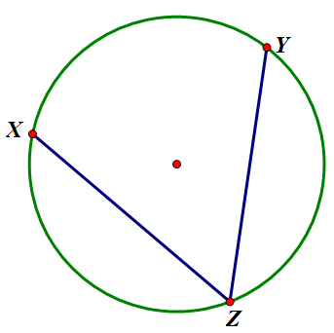2. If the angle is an inscribed angle, name it and 3. If $∠XZY is 44°,$

name the intercepted arc. Multiple Choice

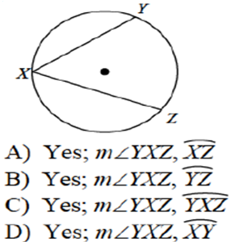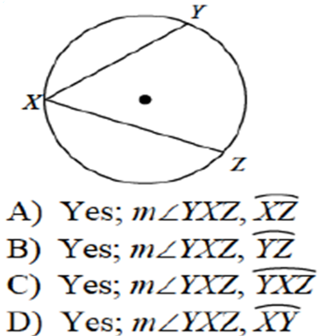

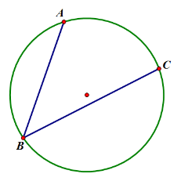

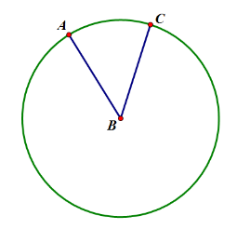

4. If 5. If

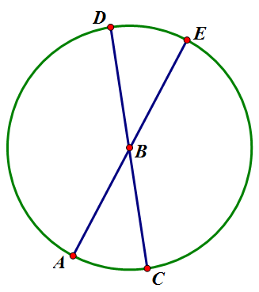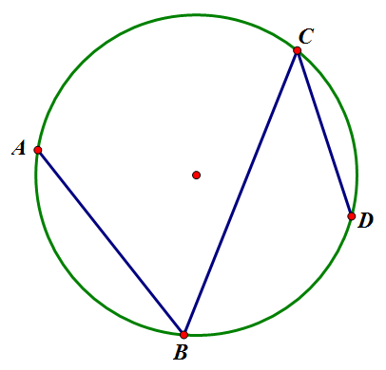

6. If 7. If

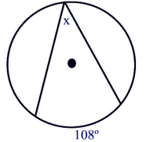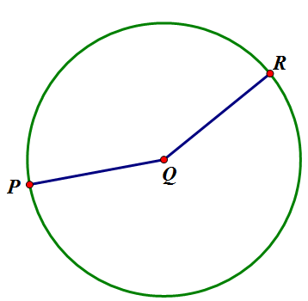8. If $\hat{PR} is 164°,$ 9. Solve for $x$.

$∠PQR=_________$

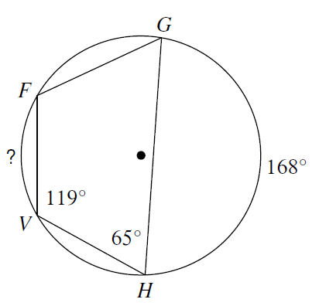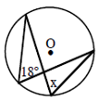10. Solve for $x.$ 11. Solve for .

12. Solve for $\hat{DC}$. 13. Solve for $x$.

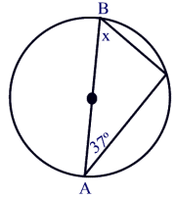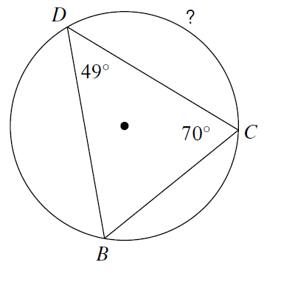

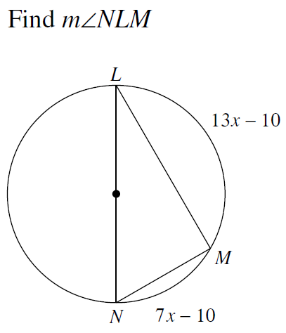

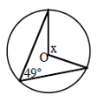14. Solve for $x$. 15.

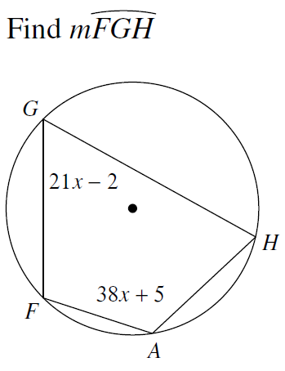

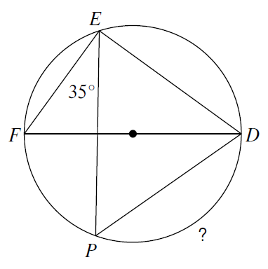16. 17. Solve for $\hat{PD}$.