Homework 6.3 – Chord Relationships – Honors Name: __________________________
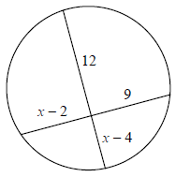
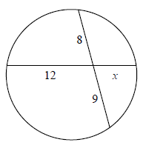
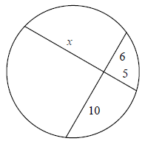
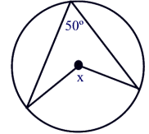
1. Solve for x. 2. Solve for x. 3. Solve for x. 4. Solve for x.

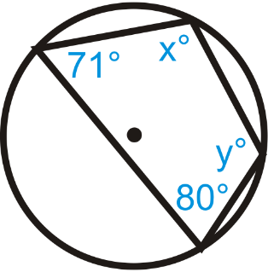
5. Solve for $∠x$ and $∠y$. 6. Solve for x. 7. Solve for $∠ABC \& ∠EBD$.
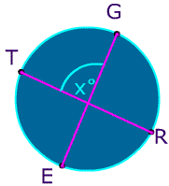
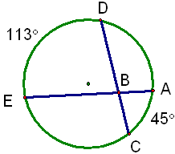
$\hat{TG}=75°, \hat{ER}=65°$

Homework 6.3 – Chord Relationships – Honors Name: __________________________
1. Solve for x. 2. Solve for x. 3. Solve for x. 4. Solve for x.

5. Solve for $∠x$ and $∠y$. 6. Solve for x. 7. Solve for $∠ABC \& ∠EBD$.
$\hat{TG}=75°, \hat{ER}=65°$

