Homework 4.2 – Vertex Form – Day 2 Name: ___________________________

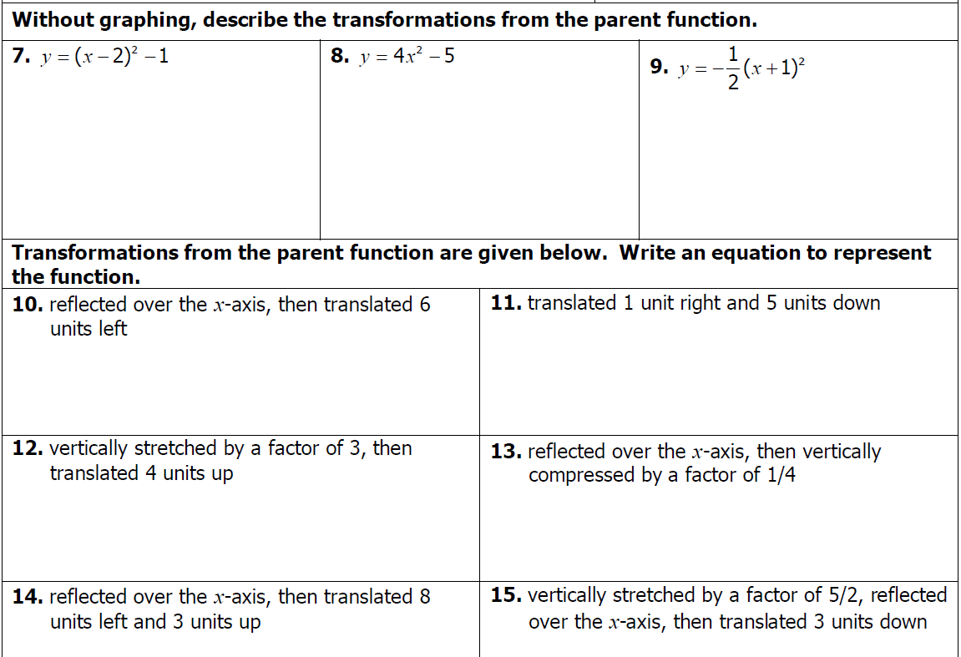

Homework 4.2 – Vertex Form – Day 2 Name: ___________________________

