Homework 7.2 – Other Regressions Name: ____________________________________________

- The graph below shows a line of best fit for data collected on the value of used cars in relation to the number of years since they were purchased. What is the equation of the line of best fit?
[a] $y=750x+9,500$

[b] $y=-750x+11,000$

[c] $y=\frac{3}{4}x+11$

[d] $y=-\frac{3}{4}x+11,000$

- Beverly did a study this past spring using date she collected from a cafeteria. She recorded the data weekly for ice cream sales and soda sales. Beverly found the line of best fit and the correlation coefficient, as shown in the diagram below. Given this information, which statement(s) can be correctly concluded? Select all that apply.
[a] Eating more ice cream causes a person to become thirsty.

[b] Drinking more soda causes a person to become hungry.

[c] There is a strong correlation between ice cream and soda sales.

[d] A curve of best fit would be better than a line of best fit.

[e] As ice cream sales go up, soda sales also go up

[d] As ice cream sales go up, soda sales go down

For #3-6 describe what type of function would best fit the scatter plot data.
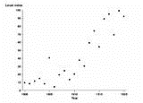
3. 4.

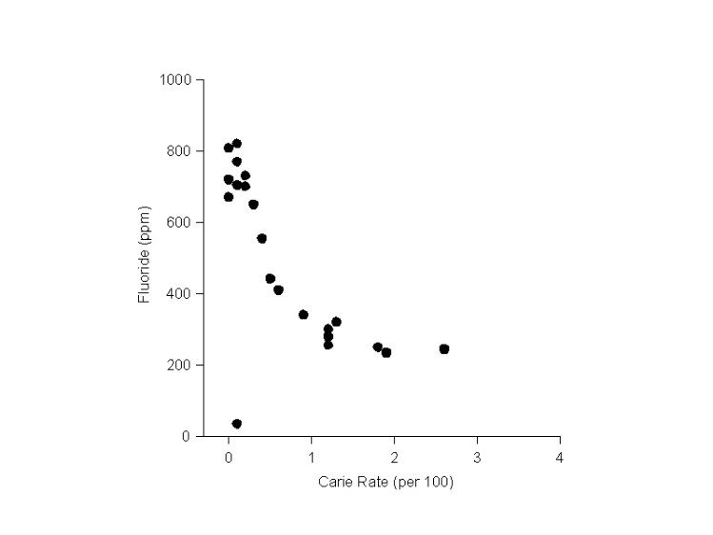
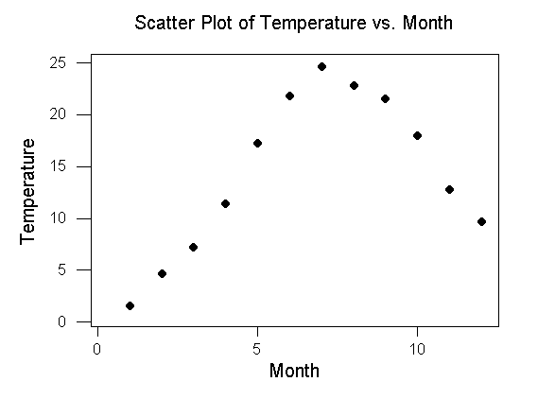
5. 6.

