Algebra 1 Final Review Name: ____________________________

1. Solve $x^{2}-3x-10=0$ _____________________

2. Solve $(2x-3)(x+4)=0$ __________________

3. Find the vertex of $x^{2}+2x-8$ ___________________________

4. Find the axis of symmetry of $x^{2}+6x+5$ ___________________

5. If $f\left(x\right)=3x-7$, find $f(-2)$ _______________

6. If $f\left(x\right)=3x-7$, find x when $f\left(x\right)=17$ ________________

7. Given a = 4, b = -2, c = 5, evaluate: $a^{2}-c+2b$ ___________________

8. What is the slope of (5, 4) and (-2, 6)? __________________

9. If $f\left(x\right)=2^{x}$, what is $f(4)$? _____________

10. Stacy has $500 in her bank account. She wants to save money for a car and plans on depositing $60 each week, $x$. Write a function/expression that represents this situation. ___________________________

11. How many weeks will Stacy have to save in Problem 10, if the car she wants is $4,500? ______________

12. Kristin spent $131 on shirts. Name brand shirts, $x$, cost $28 and regular shirts, $y,$ cost $15. She bought a total of 7
Shirts. Write a system of equations to represent this situation. ___________________________
___________________________

13. How many of each type of shirt did Kristen buy in Problem 12? __________________ __________________

14. Given: $g\left(x\right)=49+6x$, what is the slope? _______________
15. Given the following, write a linear equation to represent the pattern. ________________
x | 0 | 1 | 2 | 3
y | 5 | 15 | 25 | 35

16. Given $f\left(x\right)= x^{2}+4 and g\left(x\right)=3^{x}$, fill in the blank with the appropriate symbol (<, ≤, =, >, ≥).
$$f\left(5\right) ____ g\left(5\right)$$

17. Given the pattern 10,000 , 5,000 , 2,500 , 1,2500 , 625,…what is the next term? ___________________

18. Given the pattern 3, 12, 48, 192, 768, 3072,… what is the FIRST term? ____________________

19. What is $f(1)$? __________________
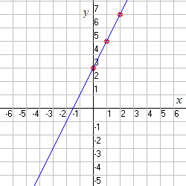

20. What is the equation of the line in #19? ______________________________________

21. Given the set of numbers: 4, 6, 6, 8, 8, 10, 10, 11, 12, 20. Find the median and the Interquartile range.
Median = __________________
IQR = __________________

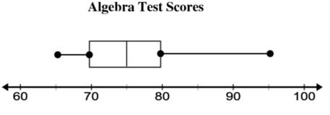
Twenty of Mr. Smith’s algebra students recently took a quiz. The results of the quiz are shown on the box-and-whiskers plot below.

22. What score was greater than or equal to 75% of all other scores on the quiz?

23. Mr. Smith regularly sets the passing score on his quizzes to be the score of the lower quartile. What is the passing grade on the quiz?

Use the following to answer questions 24 and 25.
The average NBA athlete’s salary is given below in the table.
Years since 1980 | Annual Salary  (thousands of dollars)
0 | 135
5 | 320
10 | 805
15 | 2000
16 | 2405
17 | 2890
18 | 3460

24. When graphed, the data set above is an example of a(n) __________________ scatterplot.

25. Using technology, calculate the regression in the form that is suitable for the scatterplot. What is the equation of the regression in the correct form?

