Final Exam Study Guide – Geometry Name: ____________________________________

STUDY YOUR STUDY GUIDE!!
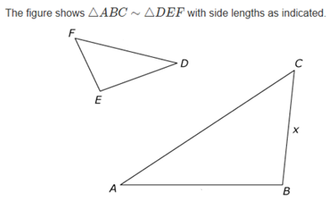
49
10
6
21
14
1.

Find the value of $x.$

2.

What is the arc length of $\hat{CD}$?

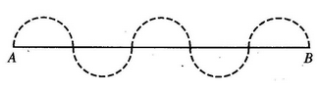
3.

In the figure above, the diameters of the 5 dotted semicircles are equal and lie on the line segment AB. If the length of the line segment AB is 20, what is the length of the dotted curve from A to B ?

4.

5.

Based on the figure, which of the individual statements would provide enough information to conclude that line r is perpendicular to line p ?

Select all that apply.
- $m∠2=90°$
- $m∠6=90°$
- $m∠3=m∠6$
- $m∠1+m∠2=90°$

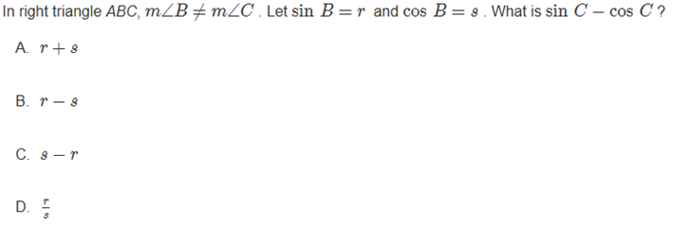
6.

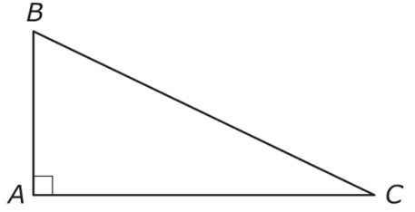

7.

$$V=\frac{1}{3}∙h∙area of base$$

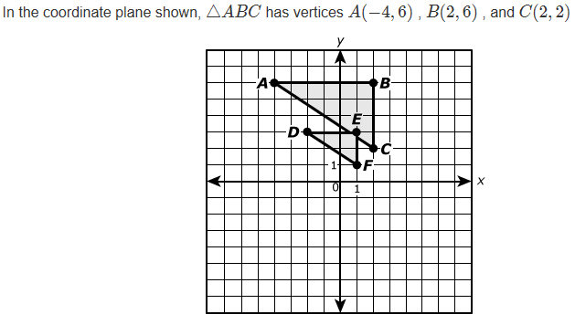
8.
What is the scale factor that will carry $∆ABC$ onto $∆DEF$?

9. Phoebe stands on level ground, 50m away from the foot of a building known to be 174.6m high. What will the angle of elevation be to the top of the building?

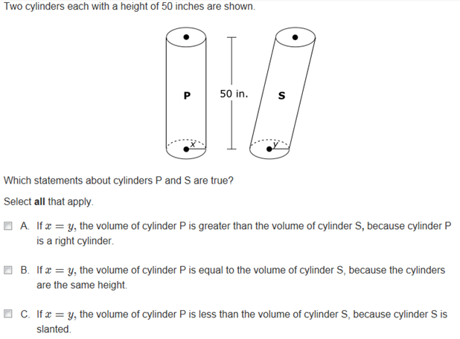
10.

$$V=πr^{2}h$$

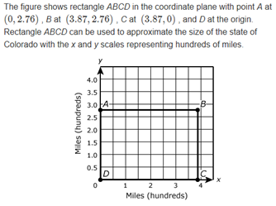
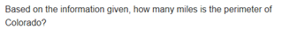
11.

12. The equation $x^{2}+y^{2}+12x-26y=c$ describes a circle.

Determine the center of the circle.

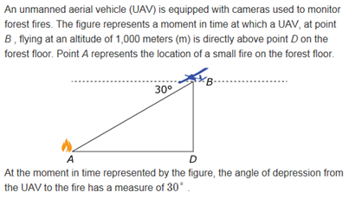
13.
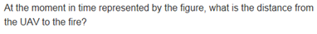

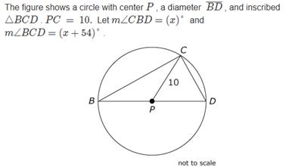
14.

Find the value of $x.$

15. The equation $x^{2}-16x+y^{2}=17$ defines a circle in the $xy-$coordinate plane.

Circle the correct answer for both boxes:

$$17$$

$$25$$

$$33$$

$$81$$
$$x-16$$

$$x-32$$

$$x-8$$

$$x+8$$

16.

Circle the answers in the boxes to complete the sentence:

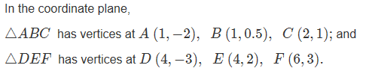
17.

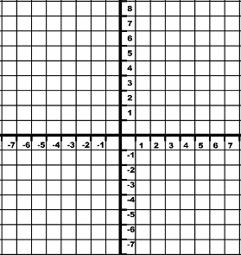

$∆ABC\sim ∆DEF$. What is the scale factor for this similarity if $∆ABC$ is being mapped onto $∆DEF$?

18.

19.

20. Find the midpoint of the segment containing the end points $X\left(-15, 8\right)$ and $Y(9, 20)$.

