Practice – Equations of Circles Name: ________________________________

Due Monday – Quiz on Equations of Circles is Wednesday

Rewrite each equation and identify the center of the circle and the radius length.

1. $x^{2}+4x+y^{2}=36$ Center:

Radius:

2. $x^{2}-10x+y^{2}+8y=23$ Center:

Radius:

Verify if (5, 4) is on the circle:

3. $x^{2}+y^{2}+2x-6y=-7$ Center:

Radius:

Verify if (-3, -6) is on the circle:

4. $y^{2}+x^{2}+6x-8y=0$ Center:

Radius:

Verify if (-7, 1) is on the circle:

5. $x^{2}+y^{2}+6x-14y=12$ Center:

Radius:

6. $x^{2}+y^{2}-8x-4y+18=0$ Center:

Radius:

7. What is the center and radius of the circle whose equation is ${(x+16)}^{2}+{(y+15)}^{2}=100$

8. Identify the center and radius of the circle: ${(x-4.5)}^{2}+{(y+9)}^{2}=12.25$

9. Write the equation of the circle whose center is at (8, -7) with a radius of 9.

10. Write the equation of the circle whose center is at (-23, 11) with a radius of 12.

11. Write the equation of the circle whose center is at (-6, 4) and a point on the circle is (-6, 8).

12. Write the equation of the circle whose center is at (3, 3) and a point on the circle is (9, 3).

13. Rewrite the equation of this circle in expanded form. ${(x+3)}^{2}+{(y-4)}^{2}=9$

14. Write the equation of the given circle: 15. Write the equation of the given circle:
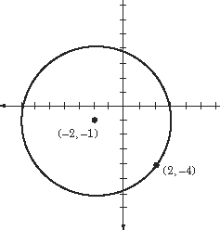
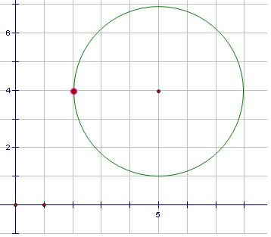

16. Use the information provided to write the equation of the circle.
Ends of a diameter: (18, -13) and (4, -3)

